**Triggers:**

Triggers in PL/SQL are special types of stored procedures that are automatically executed or fired in response to certain events on a particular table or view.

The code to be fired can be customized.

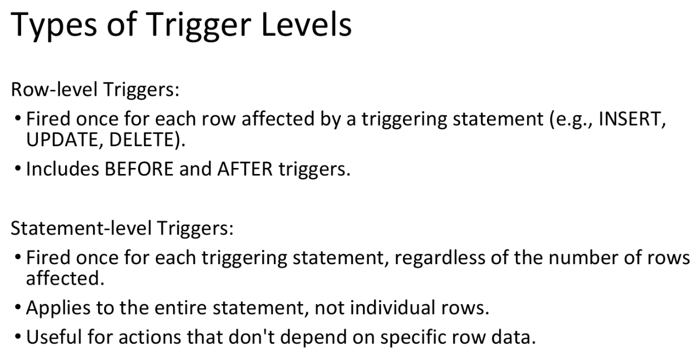

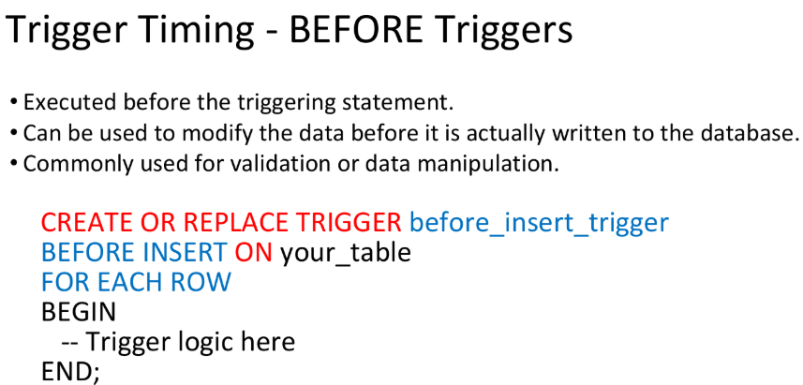

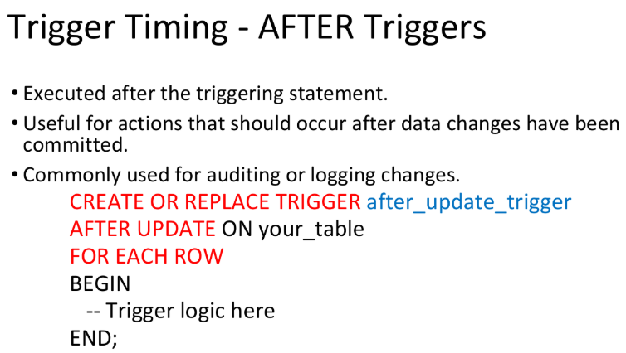

**Trigger Events**

**INSERT Trigger:** Fired when a new row is inserted into the table.

**UPDATE Trigger:** Fired when one or more columns of an existing row are updated.

**DELETE Trigger:** Fired when a row is deleted from the table.

**Instead of Triggers:** Used for views to replace the default DML behavior. Enables custom actions when INSERT, UPDATE, or DELETE operations are attempted on a view.

Instead-of triggers are a type of database trigger used primarily in Oracle databases. They are specifically designed to work with views. Unlike traditional triggers that fire before or after an INSERT, UPDATE, or DELETE operation on a table, instead-of triggers fire "instead of" the actual DML operation on a view.

When you perform an INSERT, UPDATE, or DELETE operation on a view that has an instead-of trigger, the trigger's code executes instead of the actual DML operation. This allows you to control exactly what happens when a user attempts to modify data through the view.

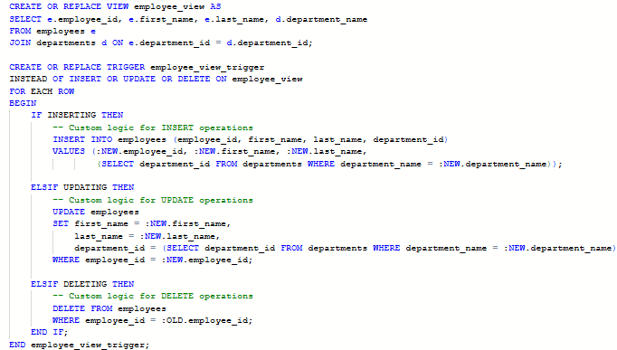

**Explanation**

* **View Definition**: The employee_view is a join view that combines data from the employees and departments tables.
* **Trigger Definition**: The employee_view_trigger is defined to fire instead of INSERT, UPDATE, or DELETE operations on the employee_view.
* **Custom Logic**: The trigger includes custom logic for each type of DML operation. For example, when inserting a new record through the view, the trigger inserts the record into the employees table and resolves the department_id based on the department_name.

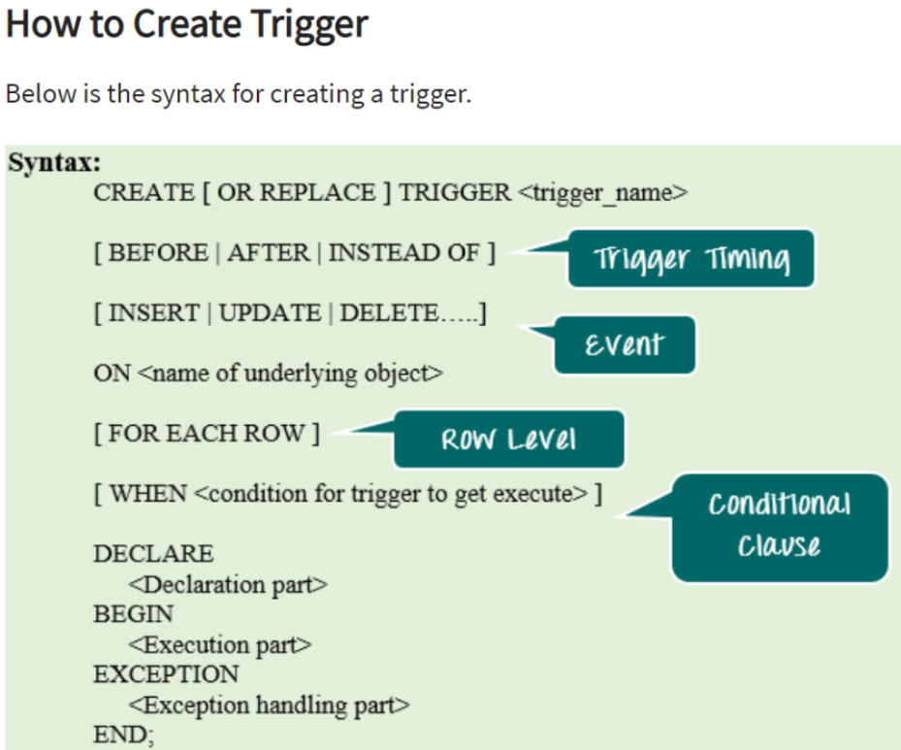

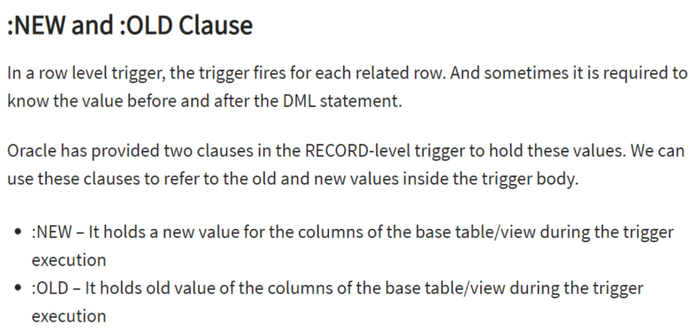

**Q: Create a trigger when view_table is about to update by using instead of trigger. View_table contains three suitable columns from employee table and 2 suitable columns from department**

